

Dr. Brittany, Myers inc.

2018-03-18

Dr. Myers

9419 Sherri Wall, Katherinemouth, MA 67522

Phone: 807378348

Fax: 5138572613

**Re:** Joanna, Garcia

**PHN:** 27922795

**Birthdate:** 01-May-1945

**Address:** PSC 3586, Box 6273, APO AE 84947

**Patient number:** 8080319534

To Whom It May Concern:

This is a medical letter to state the above patient is pregnant with expected delivery date of 15-Apr-2025. Hoping this information is satisfactory for your requirements.

Thank you.

Sincerely,

Dr. Brittany, Myers

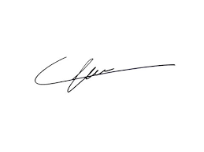

FRCS© NCMP

Clinical Assistant Professor, UBC

Department of Obstetrics and Gynecology SMH